Introduction:

A fire on board a ship can have disastrous consequences, and as good as the evacuation plans may be now, they will need improvement to ensure that as many passengers as possible survives. We have worked on modifying existing algorithms that attempts to find the optimal path of evacuation during a simulated crisis, and which could one day be used to help save lives during a crisis that otherwise may have been lost.

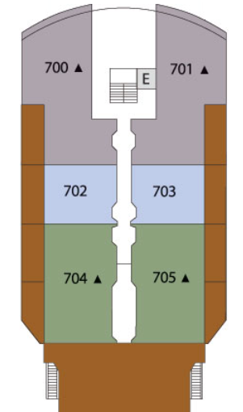
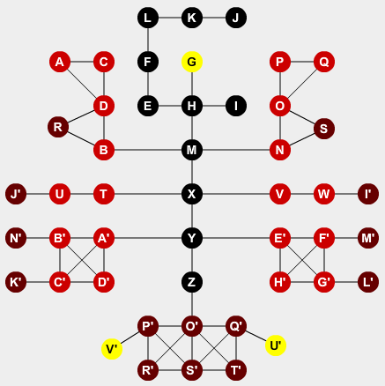
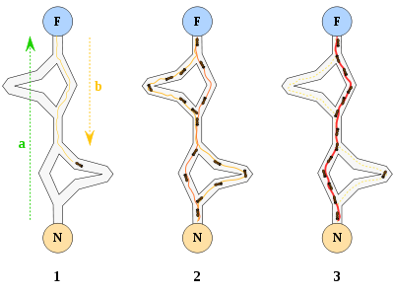
Step one shows that the first virtual ant finding one out of multiple paths from the start to the goal. Step two shows multiple ants exploring all paths and finally in step three the shortest path is established. [1]

Our main focus was the Ant Colony Optimization, a pathfinding algorithm which finds a path through the environment to the desired destination by mimicking the behavior of an ant colony. The algorithm sends out virtual ants that search for a valid path then report back the path they took. These paths are marked with pheromones and any consecutive ants are more likely to walk on the previously successful paths.

Methods:

In our thesis we have compared Dijkstra's pathfinding algorithm to ACO, as Dijkstra's is one of the most commonly used pathfinding algorithms today. We modeled the ships as dynamic graphs with nodes and edges where the nodes could be rooms, hallways or other sections of the ships and the edges indicate that it were possible to transition from one node to another. The simulated passengers received directions on their smart phones and we assumed for that everyone had one.

Real ship blueprints were converted into graphs, here color coded to show the process. [2]
Additionally, we have simulated human behavior during a crisis and observed how this affected the algorithms. Finally we looked into how high occupant density around exits slowed down the evacuation process and explored how to redirect passengers.

Results:

In the simulations we ran there were several parameters that were changed and multiple variables that had an extreme impact on the simulation. For instance the ﬁres could cover all exits and end up killing most if not all passengers. Thus each simulation ran 200 times and we obtained the average results.

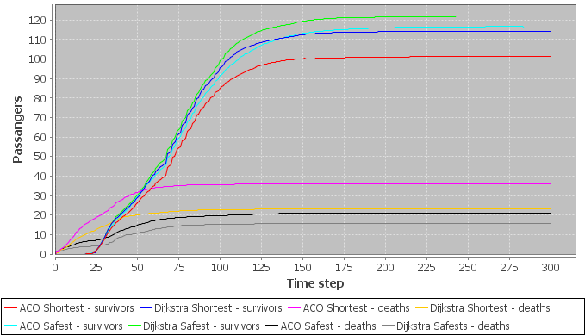

[400px-Aco_branches.svg] n.d. [image online] Available at: <http://upload.wikimedia.org/wikipedia/commons/thumb/a/af/Aco_branches.svg/400px-Aco_branches.svg.png> [Accessed 04 June 2013].

